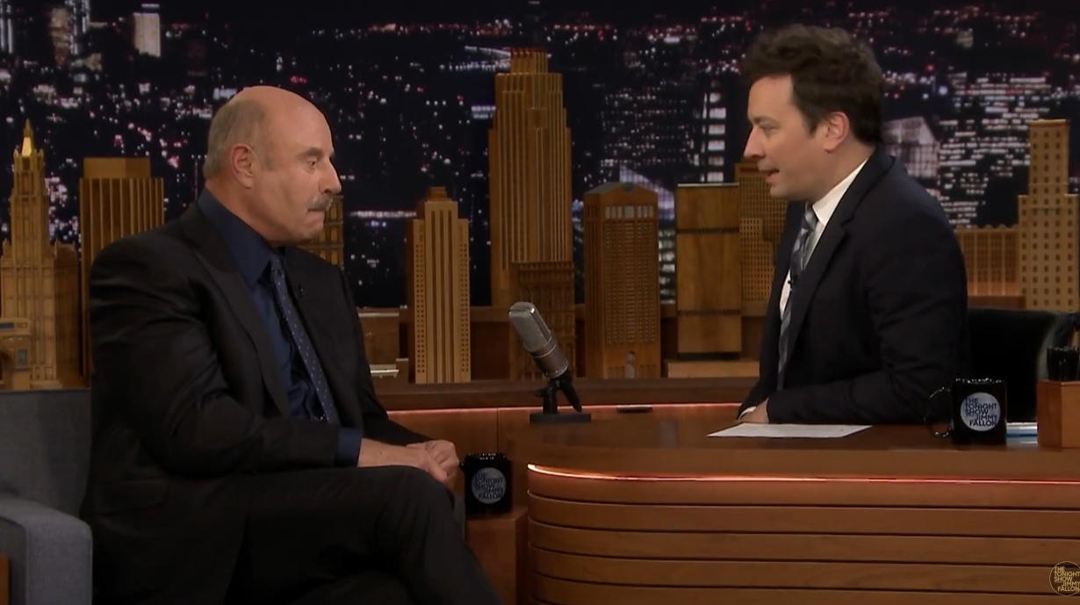

1. Watch the following video and answer the questions: https://www.youtube.com/watch?v=DX5bM9ttefw

a. Have Jimmy Fallon and Dr. Phil McGraw played this game before?
b. Which were the rules that Dr. Phil McGraw explained?
c. Which were the three possible truths/lies?
d. Which were the questions that Jimmy Fallon asked and their answers or explanations?
e. Which one was Jimmy Fallon’s guess? Which one was a lie? Did you think the same?
f. Which is the final explanation about the “cow’s part on a shoulder” line?

